1. User Management

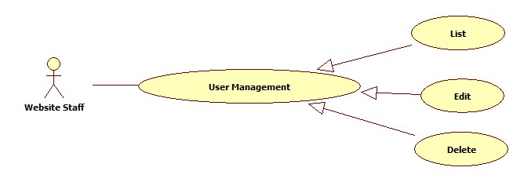

* 1. User View Management

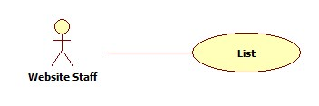

|  |  |  |  |  |
| --- | --- | --- | --- | --- |
| **USE CASE-n SPECIFICATION** | | | | |
| **Use-case No.** | <UC001> | **Use-case Version** | | <1.0> |
| **Use-case Name** | User List Management | | | |
| **Author** | KhanhNQ | | | |
| **Date** | 12/02/2014 | **Priority** | High | |
| **Actor:**  Website Staff  **Summary:**  This use case describe how to List all user in website  **Goal:**  List all User in Website  **Triggers:**  Actor click on List button to view one of all User in website  **Preconditions:**  N/A  **Post-conditions:**    **Main Success Scenario:**   |  |  |  | | --- | --- | --- | | Step | Actor Action | System Response | | 1 | Click on user want to list | The system will show the information with user |   **Alternative Scenario:**     |  |  | | --- | --- | | Actor Action | System Response | | Click on Homepage link to end list | System will transfer to “Homepage” |   **Exceptions:**  N/A  **Relationships:**  N/A  **Business Rules:**  N/A | | | | |

* 1. User Edit Management

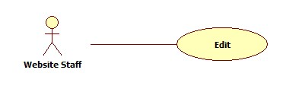

|  |  |  |  |  |
| --- | --- | --- | --- | --- |
| **USE CASE-n SPECIFICATION** | | | | |
| **Use-case No.** | <UC001> | **Use-case Version** | | <1.0> |
| **Use-case Name** | User Edit Management | | | |
| **Author** | KhanhNQ | | | |
| **Date** | 12/02/2014 | **Priority** | High | |
| **Actor:**  Website Staff  **Summary:**  This use case describe how to Edit all user in website  **Goal:**  Manager all User in Website  **Triggers:**  Actor click on Edit button to Edit one of all User in website  **Preconditions:**  N/A  **Post-conditions:**    **Main Success Scenario:**   |  |  |  | | --- | --- | --- | | Step | Actor Action | System Response | | 1 | Click on Edit button to change User Information | The system will show the User Information Page | | 2 | Click on field want to edit and change the last info |  | | 3 | Click on Save button to save information | The system will show the User with page of new information |   **Alternative Scenario:**     |  |  | | --- | --- | | Actor Action | System Response | | Click on Cancel button to cancel | System will transfer to “Homepage” |   **Exceptions:**  N/A  **Relationships:**  N/A  **Business Rules:**  N/A | | | | |

* 1. User Delete Management

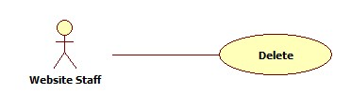

|  |  |  |  |  |
| --- | --- | --- | --- | --- |
| **USE CASE-n SPECIFICATION** | | | | |
| **Use-case No.** | <UC001> | **Use-case Version** | | <1.0> |
| **Use-case Name** | User Management | | | |
| **Author** | KhanhNQ | | | |
| **Date** | 12/02/2014 | **Priority** | High | |
| **Actor:**  Website Staff  **Summary:**  This use case describe how to Delete all user in website  **Goal:**  Delete all User in Website  **Triggers:**  Actor click on Delete button to delete with all User in website  **Preconditions:**  N/A  **Post-conditions:**    **Main Success Scenario:**   |  |  |  | | --- | --- | --- | | Step | Actor Action | System Response | | 1 | Click on Delete button to delete the user | The system will delete the user from the database |   **Alternative Scenario:**     |  |  | | --- | --- | | Actor Action | System Response | | Click on Cancel button to cancel | System will transfer to “Homepage” |   **Exceptions:**  N/A  **Relationships:**  N/A  **Business Rules:**  N/A | | | | |

1. Advertising Management

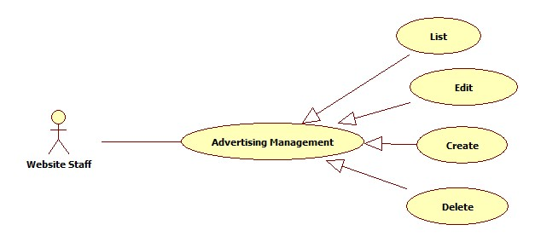

* 1. Advertising List Management



|  |  |  |  |  |
| --- | --- | --- | --- | --- |
| **USE CASE-n SPECIFICATION** | | | | |
| **Use-case No.** | <UC001> | **Use-case Version** | | <1.0> |
| **Use-case Name** | Advertising List Management | | | |
| **Author** | KhanhNQ | | | |
| **Date** | 12/02/2014 | **Priority** | High | |
| **Actor:**  Website Staff  **Summary:**  This use case describe how to List all advertising in website  **Goal:**  List all Advertising in Website  **Triggers:**  Actor click on Advertising to list one with all Advertising in website  **Preconditions:**  N/A  **Post-conditions:**    **Main Success Scenario:**   |  |  |  | | --- | --- | --- | | Step | Actor Action | System Response | | 1 | Click on advertising which want to list | The system will show the advertising |   **Alternative Scenario:**     |  |  | | --- | --- | | Actor Action | System Response | | Click on Homepage to end this view | System will transfer to “Homepage” |   **Exceptions:**  N/A  **Relationships:**  N/A  **Business Rules:**  N/A | | | | |

* 1. Advertising Create Management

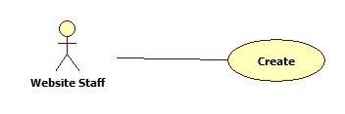

|  |  |  |  |  |
| --- | --- | --- | --- | --- |
| **USE CASE-n SPECIFICATION** | | | | |
| **Use-case No.** | <UC001> | **Use-case Version** | | <1.0> |
| **Use-case Name** | Advertising Create Management | | | |
| **Author** | KhanhNQ | | | |
| **Date** | 12/02/2014 | **Priority** | High | |
| **Actor:**  Website Staff  **Summary:**  This use case describe how to Create advertising in website  **Goal:**  Create Advertising in Website  **Triggers:**  Actor click on Create button to create Advertising in website  **Preconditions:**  N/A  **Post-conditions:**    **Main Success Scenario:**   |  |  |  | | --- | --- | --- | | Step | Actor Action | System Response | | 1 | Click on Create to create a Advertising | The system will respond to Create Advertising page | | 2 | Enter information into text fields. Click on Create button to finish | The system will create new Advertising in database. |   **Alternative Scenario:**     |  |  | | --- | --- | | Actor Action | System Response | | Click on Cancel button to cancel | System will transfer to “Homepage” |   **Exceptions:**  N/A  **Relationships:**  N/A  **Business Rules:**  N/A | | | | |

* 1. Advertising Edit Management



|  |  |  |  |  |
| --- | --- | --- | --- | --- |
| **USE CASE-n SPECIFICATION** | | | | |
| **Use-case No.** | <UC001> | **Use-case Version** | | <1.0> |
| **Use-case Name** | Advertising Edit Management | | | |
| **Author** | KhanhNQ | | | |
| **Date** | 12/02/2014 | **Priority** | High | |
| **Actor:**  Website Staff  **Summary:**  This use case describe how Edit all advertising in website  **Goal:**  Edit all Advertising in Website  **Triggers:**  Actor click on Edit button to edit with one of all Advertising in website  **Preconditions:**  N/A  **Post-conditions:**    **Main Success Scenario:**   |  |  |  | | --- | --- | --- | | Step | Actor Action | System Response | | 1 | Click on Edit button to change Advertising Information | The system will show the Advertising Information Page | | 2 | Click on field want to edit and change the last info |  | | 3 | Click on Save button to save information | The system will show the Advertising with page of new information |   **Alternative Scenario:**     |  |  | | --- | --- | | Actor Action | System Response | | Click on Cancel button to cancel | System will transfer to “Homepage” |   **Exceptions:**  N/A  **Relationships:**  N/A  **Business Rules:**  N/A | | | | |

* 1. Advertising Delete Management



|  |  |  |  |  |
| --- | --- | --- | --- | --- |
| **USE CASE-n SPECIFICATION** | | | | |
| **Use-case No.** | <UC001> | **Use-case Version** | | <1.0> |
| **Use-case Name** | Advertising Delete Management | | | |
| **Author** | KhanhNQ | | | |
| **Date** | 12/02/2014 | **Priority** | High | |
| **Actor:**  Website Staff  **Summary:**  This use case describe Delete all advertising in website  **Goal:**  Delete all Advertising in Website  **Triggers:**  Actor click on Delete button to delete with all Advertising in website  **Preconditions:**  N/A  **Post-conditions:**    **Main Success Scenario:**   |  |  |  | | --- | --- | --- | | Step | Actor Action | System Response | | 1 | Click on Delete button to delete the advertising | The system will delete the advertising |   **Alternative Scenario:**     |  |  | | --- | --- | | Actor Action | System Response | | Click on Cancel button to cancel | System will transfer to “Homepage” |   **Exceptions:**  N/A  **Relationships:**  N/A  **Business Rules:**  N/A | | | | |